1. 
2. What is motivation behind bounded Generic types.  
   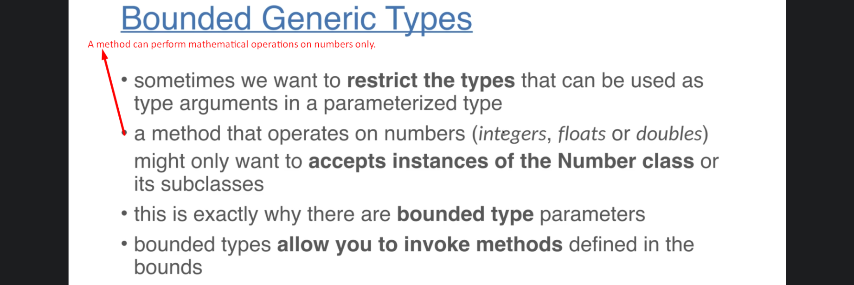
3. 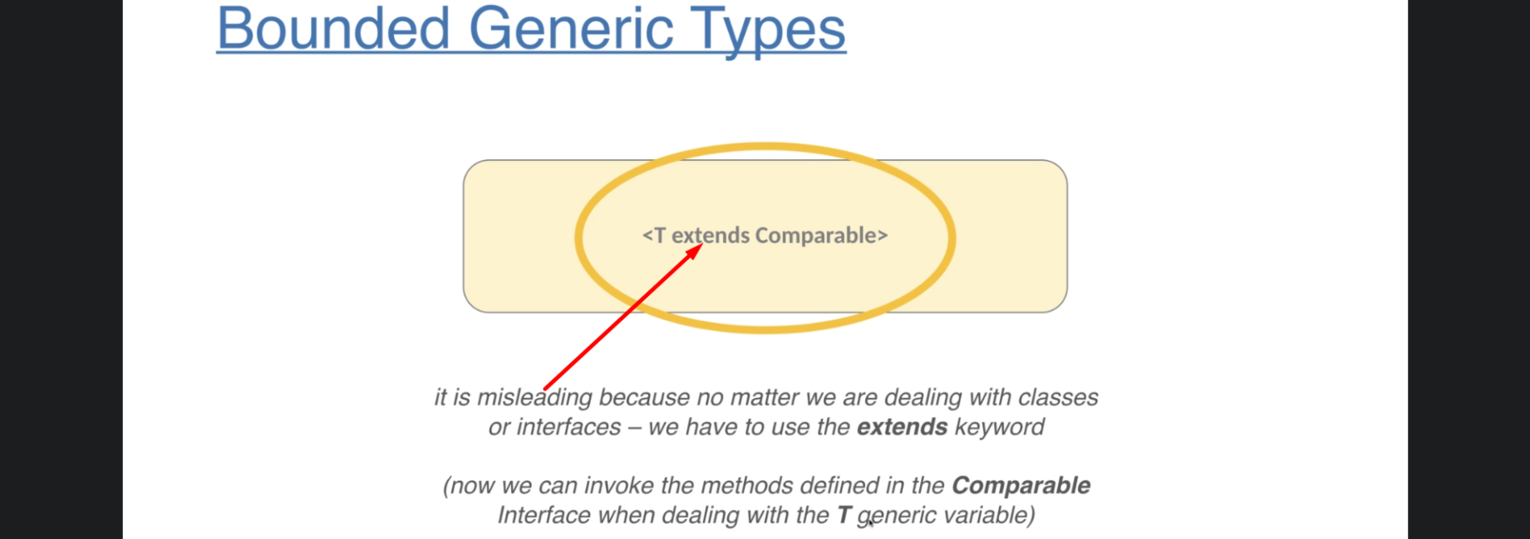
   1. We can use bounded Generic types with the help of keyword “extends”.
   2. <T extends interface_or_class>
   3. <T extends Comparable<T>>
      1. As per this bounded type, T is generic type that must implement Comprable.
4. 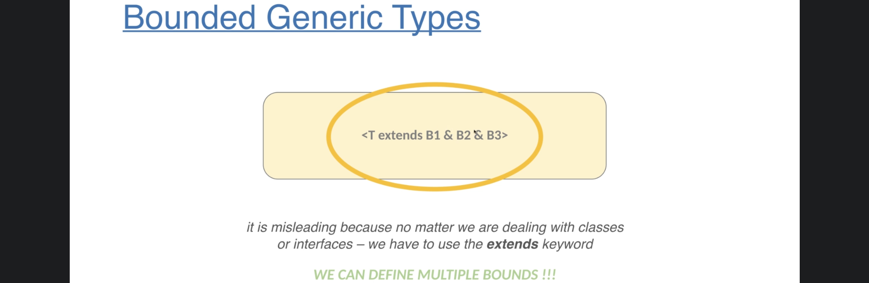
5. 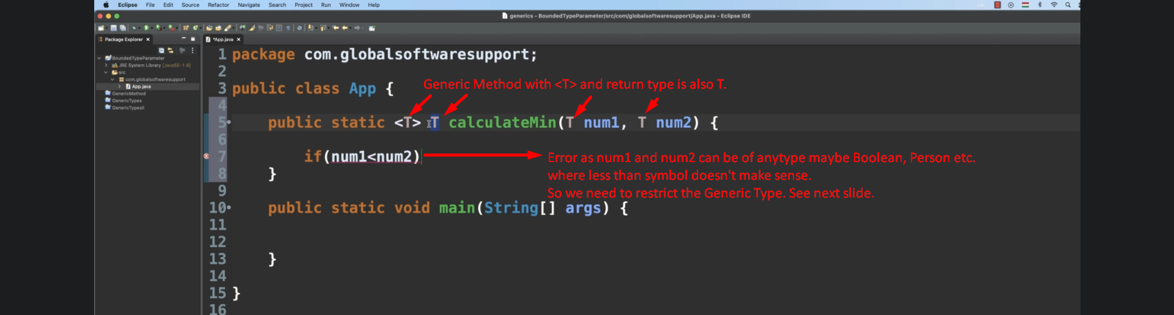
6. 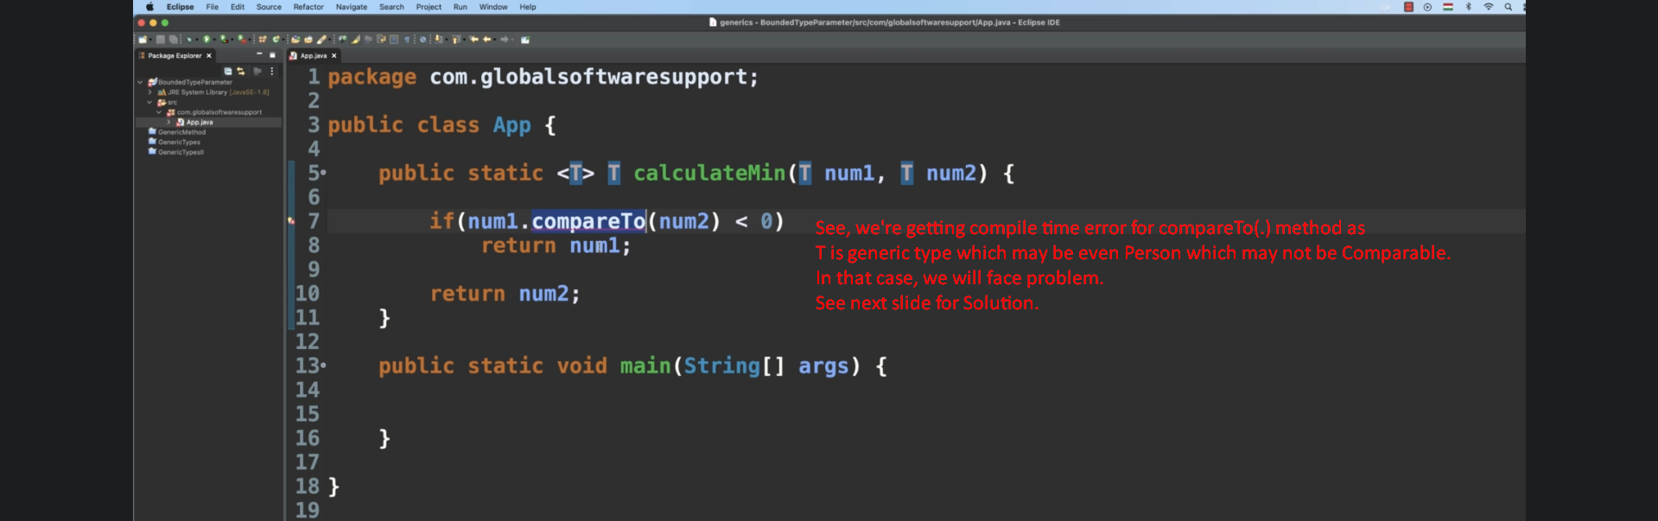
7. 